**PL SQL EXERCISES**

Exercise 1 – Control Structures

Control structures in PL/SQL are programming constructs that control the flow of execution in a PL/SQL block. They allow you to:

* Make decisions
* Perform repetitive tasks
* Control the sequence of execution

1. If Statement

DECLARE

emp_salary NUMBER := 60000;

BEGIN

IF emp_salary > 50000 THEN

DBMS_OUTPUT.PUT_LINE('Eligible for Bonus');

   END IF;

END;

Output:

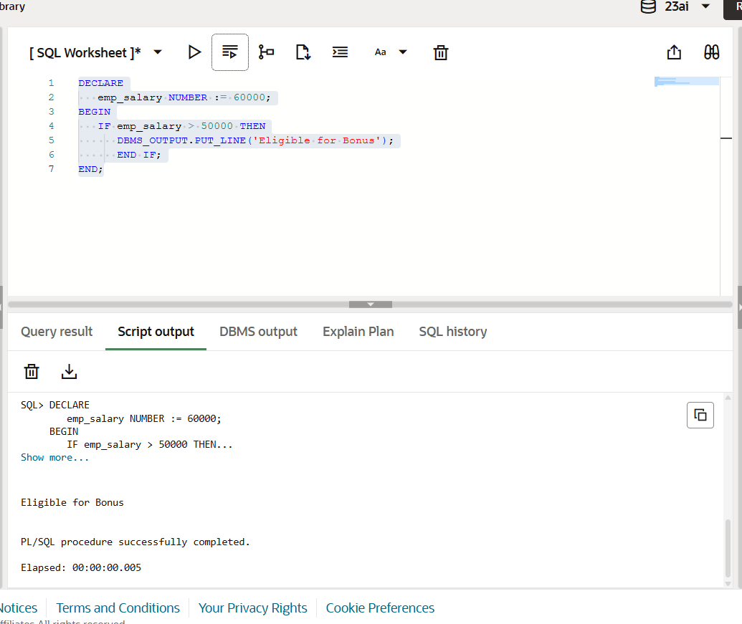

1. If Else DECLARE

student_score NUMBER := 45;

BEGIN

IF student_score >= 50 THEN

DBMS_OUTPUT.PUT_LINE('Result: Passed');

ELSE

DBMS_OUTPUT.PUT_LINE('Result: Failed');

   END IF;

END;

Output:

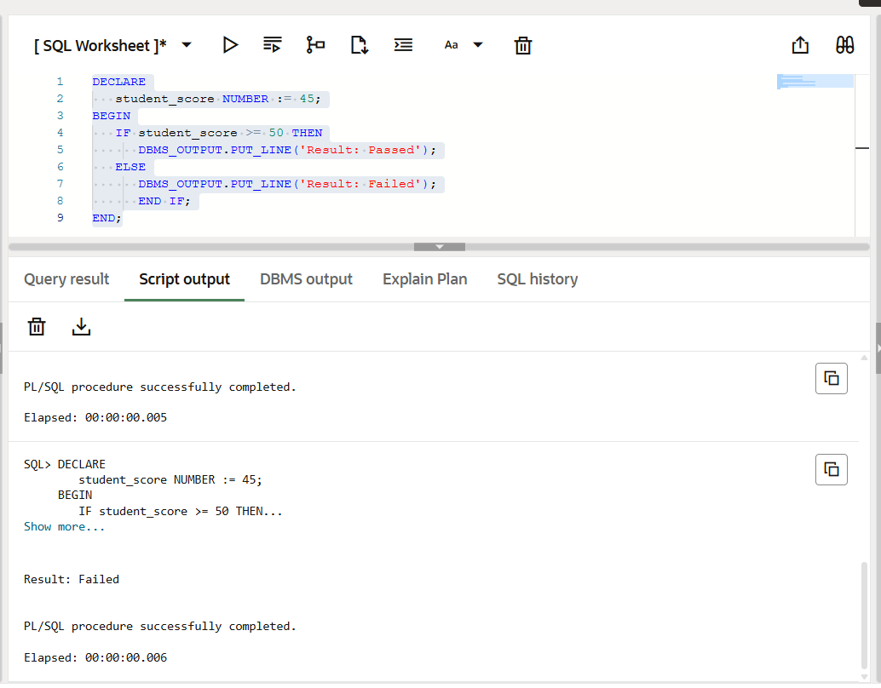

1. IF...ELSIF...ELSE Statement DECLARE

grade CHAR := 'B';

BEGIN

IF grade = 'A' THEN

DBMS_OUTPUT.PUT_LINE('Excellent');

ELSIF grade = 'B' THEN

DBMS_OUTPUT.PUT_LINE('Good');

ELSE

DBMS_OUTPUT.PUT_LINE('Needs Improvement');

   END IF;

END;

Output:

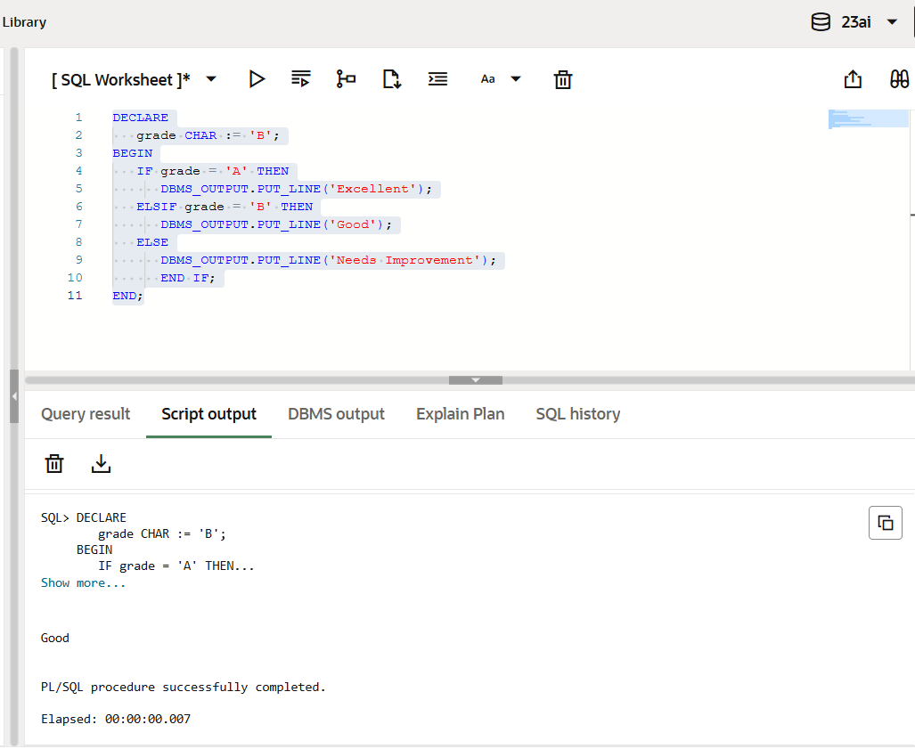

1. For Loop Statement DECLARE

i NUMBER := 1;

BEGIN

LOOP

DBMS_OUTPUT.PUT_LINE('Count: ' || i);

i := i + 1;

EXIT WHEN i > 5;

  END LOOP;

END;

Output:

1. While Loop Statement DECLARE

i NUMBER := 2;

BEGIN

WHILE i <= 10 LOOP

DBMS_OUTPUT.PUT_LINE('Even Number: ' || i);

i := i + 2;

  END LOOP;

END;

Output:

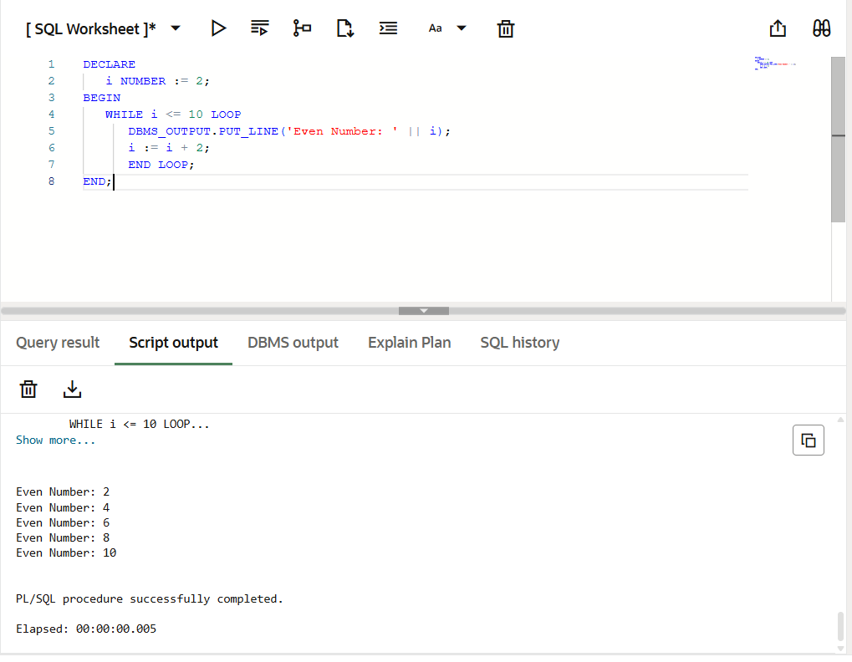

1. Nested Loops BEGIN

FOR i IN 1..3 LOOP

FOR j IN 1..3 LOOP

DBMS_OUTPUT.PUT_LINE('Row ' || i || ', Column ' || j);

END LOOP;

  END LOOP;

END;

Output:

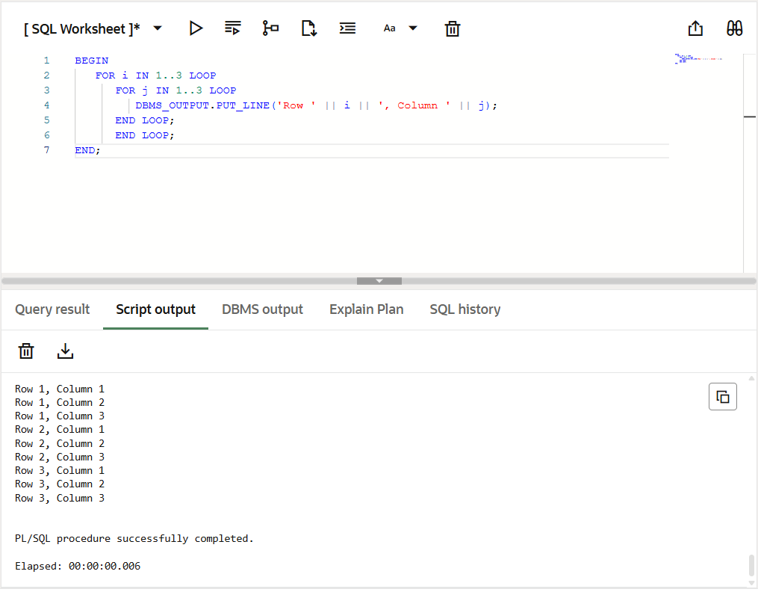

**STORED PROCEDURES**

A stored procedure is a named block of PL/SQL code that performs a specific task and is stored in the database. It can be executed (called) multiple times with different parameters.

**Key Features of Stored Procedures:**

* Encapsulate business logic
* Improve code reusability
* Increase performance by reducing network traffic
* Accept input, return output, or just perform actions
* Can be called from applications, triggers, or other procedures

Syntax:

CREATE OR REPLACE PROCEDURE procedure_name (

parameter1 IN datatype,

parameter2 OUT datatype

) IS

BEGIN

-- statements

END;

1. Stored Procedure without Parameters

CREATE OR REPLACE PROCEDURE welcome_message IS

BEGIN

DBMS_OUTPUT.PUT_LINE('Welcome to CTS Assessment!');

END;

/

BEGIN

welcome_message;

END;

/

Output:

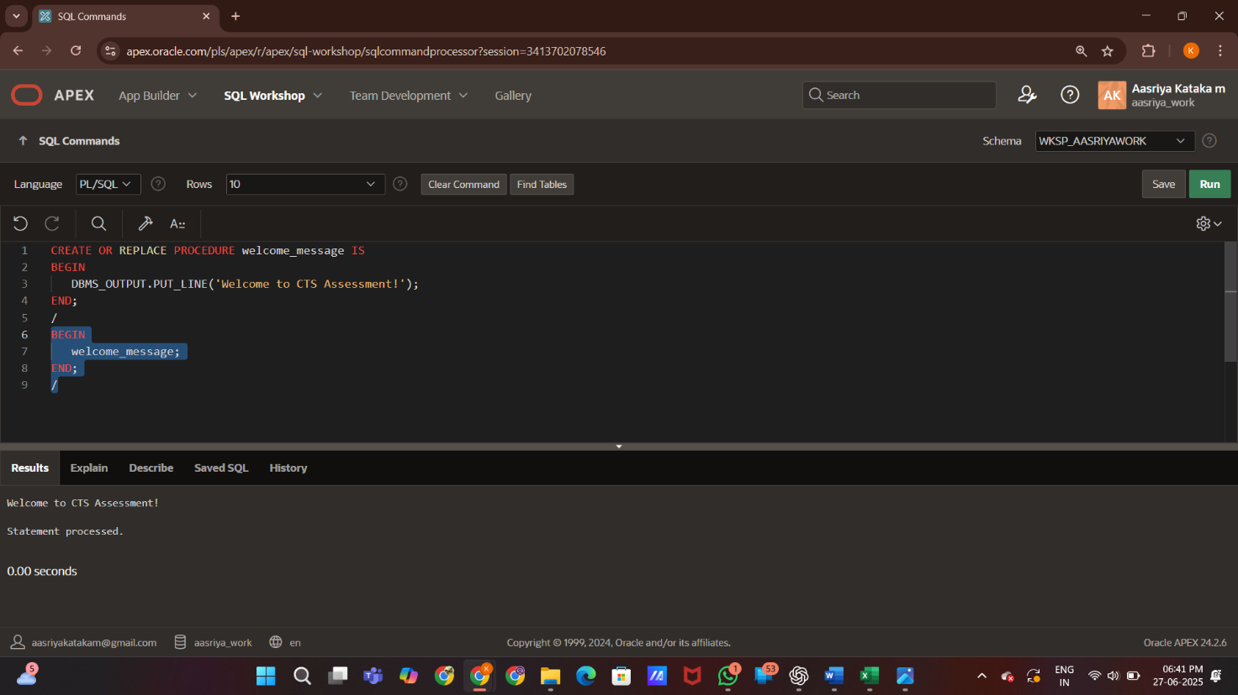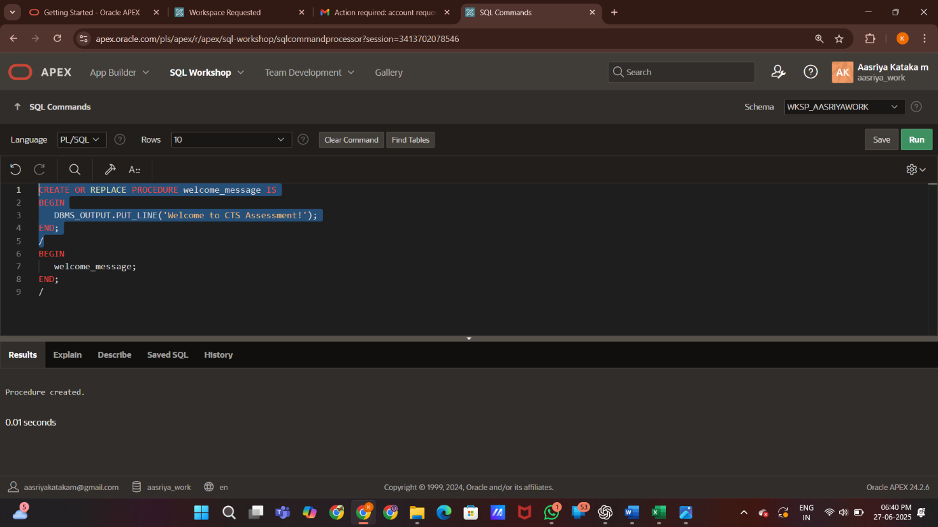

1. Stored Procedure with IN Parameter

CREATE OR REPLACE PROCEDURE greet_user(p_name IN VARCHAR2) IS

BEGIN

DBMS_OUTPUT.PUT_LINE('Hello, ' || p_name || '! Welcome!');

END;

/

BEGIN

greet_user('Anjali');

END;

/

Output:

1. 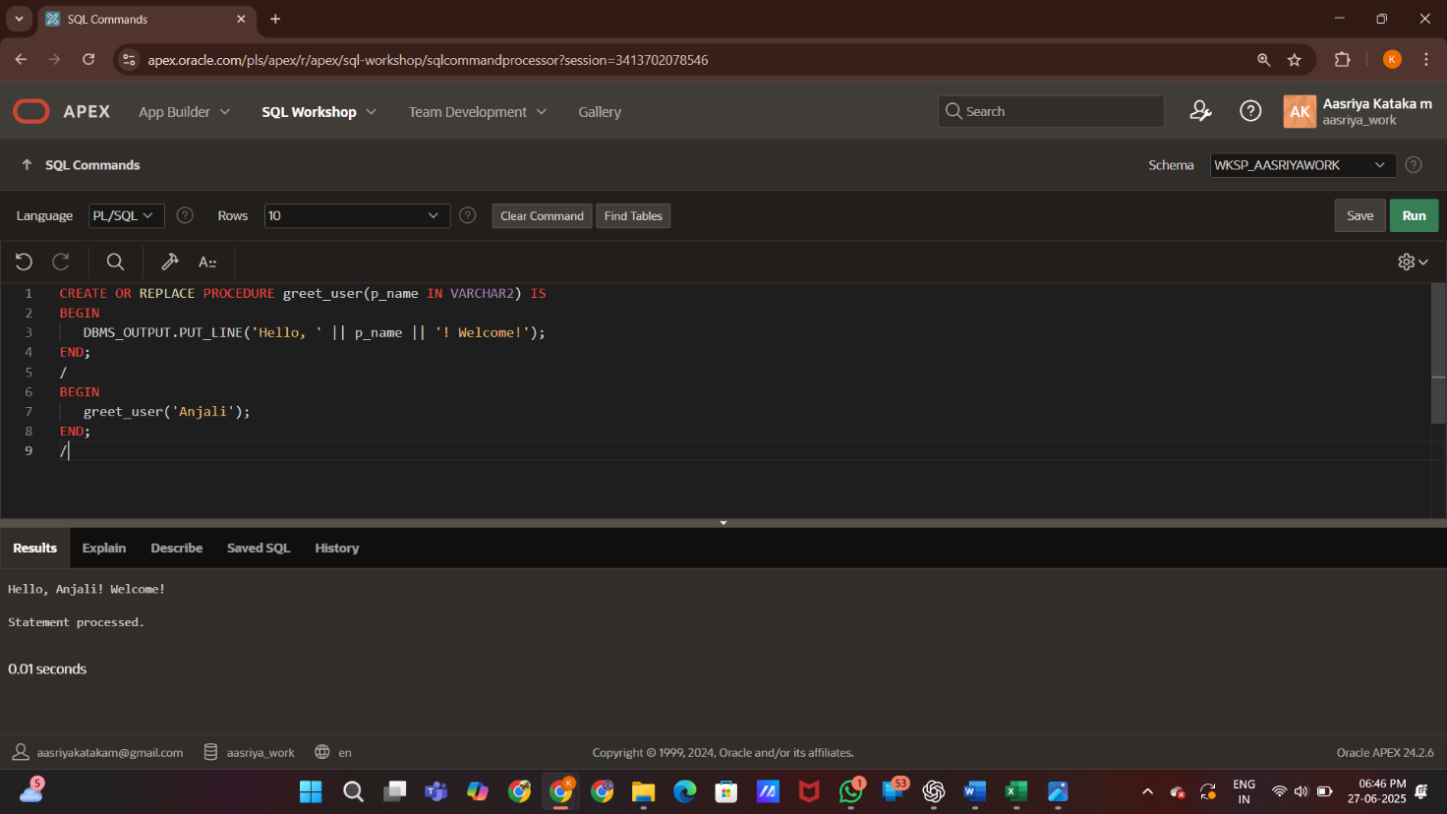Stored procedure with OUT parameter

CREATE OR REPLACE PROCEDURE square_number(

p_input IN NUMBER,

p_result OUT NUMBER

) IS

BEGIN

p_result := p_input * p_input;

END;

/

VARIABLE result NUMBER;

EXEC square_number(6, :result);

PRINT result;

Output:

1. 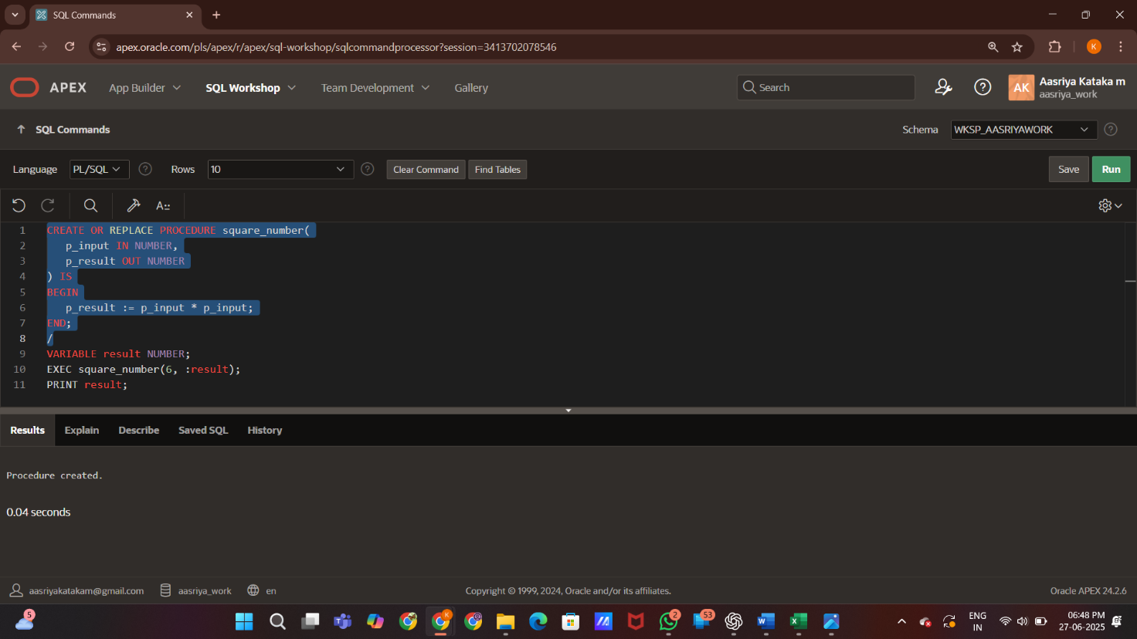Procedure to Insert into a Table

CREATE TABLE students (

student_id NUMBER,

student_name VARCHAR2(50)

);

CREATE OR REPLACE PROCEDURE add_student(p_id IN NUMBER, p_name IN VARCHAR2) IS

BEGIN

INSERT INTO students (student_id, student_name)

VALUES (p_id, p_name);

COMMIT;

END;

/

BEGIN

add_student(1, 'Aarav');

add_student(2,'Aarya');

add_student(3,'Sashi');

add_student(4,'Bunny');

END;

/

SELECT * FROM students;

Output:

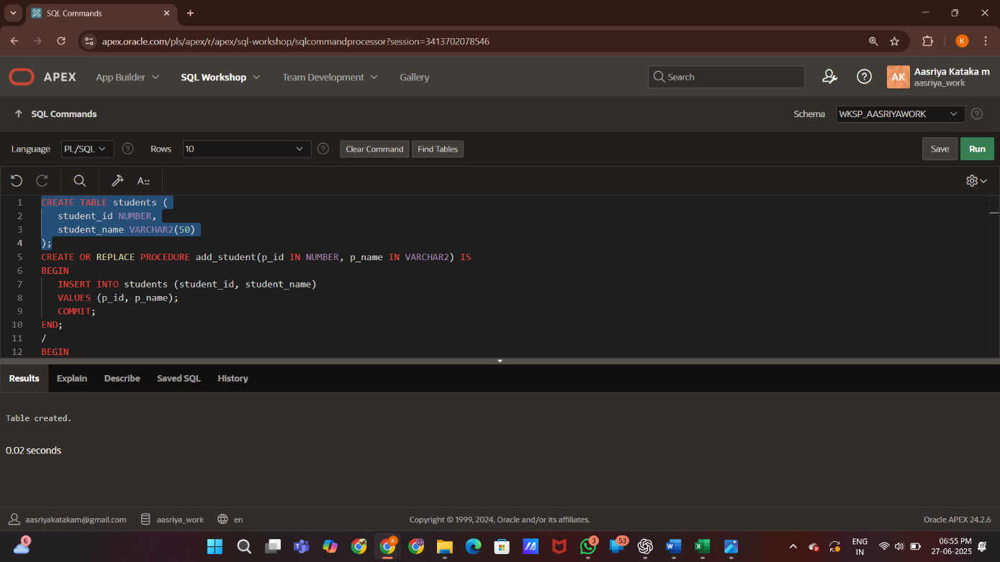

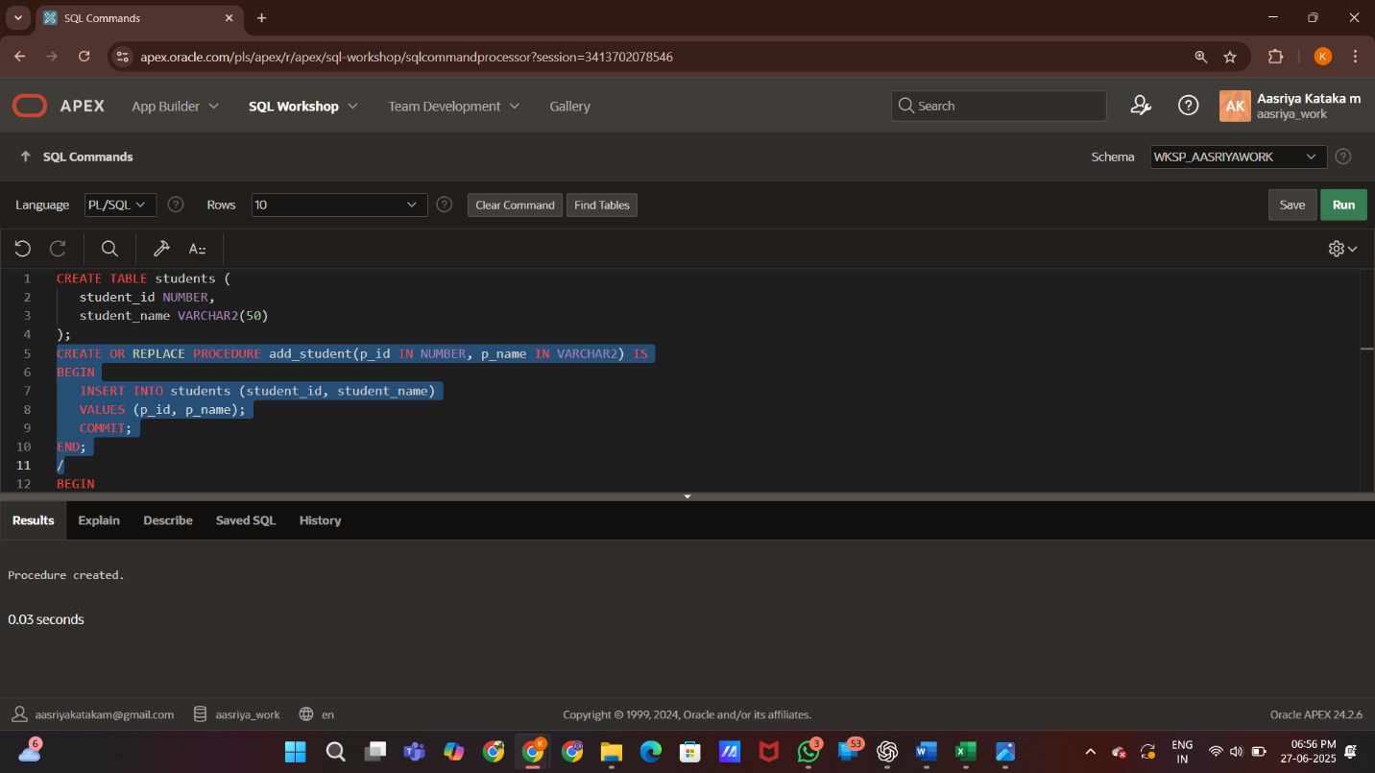

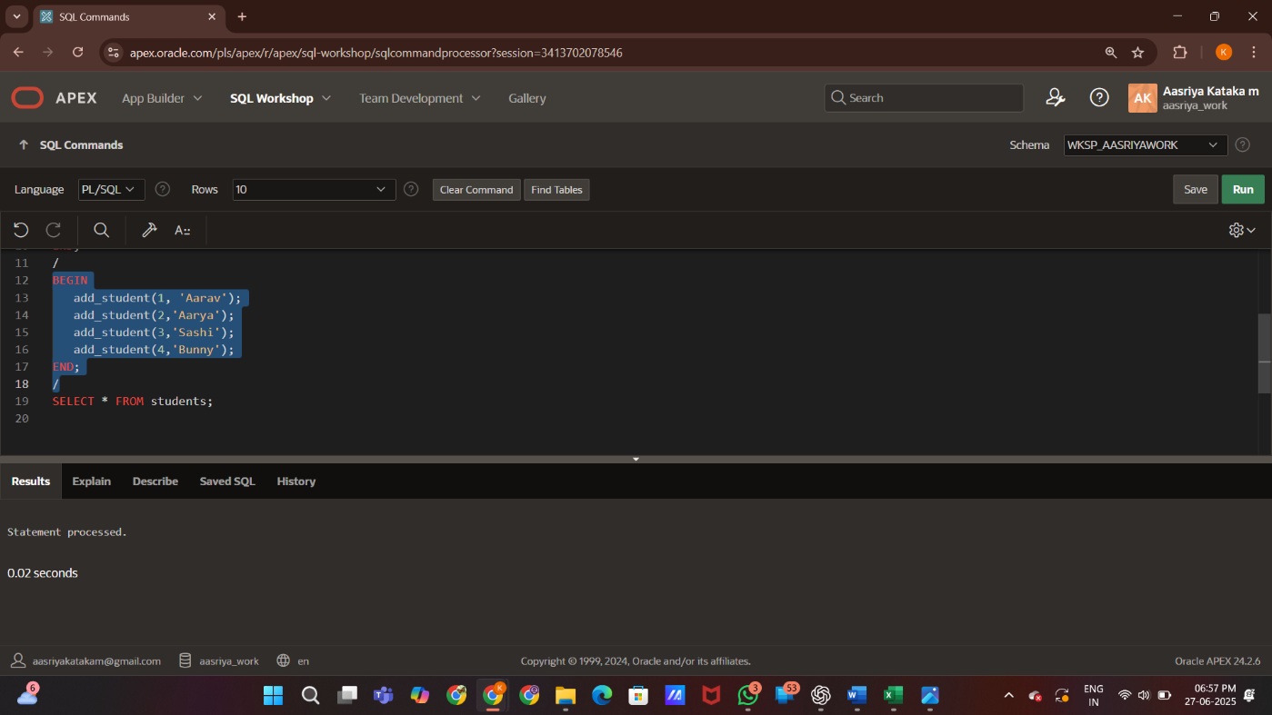

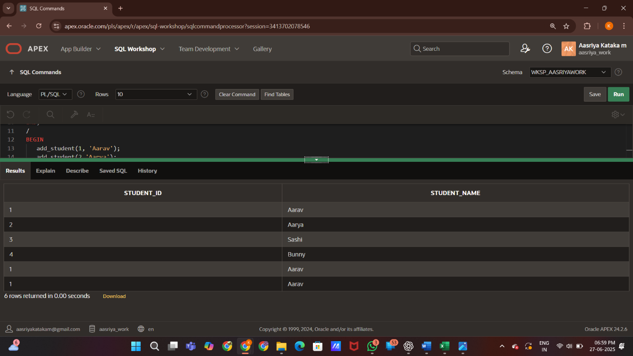

1. Procedure with IF/ELSE Logic

CREATE OR REPLACE PROCEDURE check_pass(p_score IN NUMBER) IS

BEGIN

IF p_score >= 50 THEN

DBMS_OUTPUT.PUT_LINE('Status: Passed');

ELSE

DBMS_OUTPUT.PUT_LINE('Status: Failed');

END IF;

END;

/

BEGIN

check_pass(45);

END;

/

Output:

